LAB-06
24K-0810
Task 1: TechNova Solutions has recently installed a new Cisco switch in its IT department. The network administrator normally configures the switch through a console connection, but the administrator now wants to manage the switch remotely from a workstation in the same network. The switch is connected to two departmental PCs, and the administrator needs to remotely organize the connected devices into separate VLANs and manage their switch ports. You are working as the network administrator. Configure the network in Cisco Packet Tracer according to the following requirements.
- Connect two PCs to the switch using appropriate Ethernet connections.
- Configure the switch with a suitable management IP address so that it can be accessed remotely.
- Configure the switch to allow Telnet-based remote management.
- Secure access to the switch by configuring the required authentication credentials.
- From PC1, establish a Telnet session with the switch and perform the remaining configuration remotely.
Do not use the console connection for the remaining tasks.
- The PC connected to Fa0/1 belongs to the IT Department. Create an appropriate VLAN for the IT department and assign Fa0/1 to it.
- The PC connected to Fa0/2 belongs to the HR Department. Create a separate VLAN for HR and assign Fa0/2 to it.
- Configure suitable descriptions for both switch ports so that the purpose of each port can easily be identified.
- During troubleshooting, the administrator needs to temporarily disable the HR connection. Administratively shut down Fa0/2 and verify its status. Then restore the port to its operational state.
- Use appropriate verification commands to confirm that the VLANs, port assignments, port descriptions, and port status have been configured correctly.
- Save the final switch configuration.
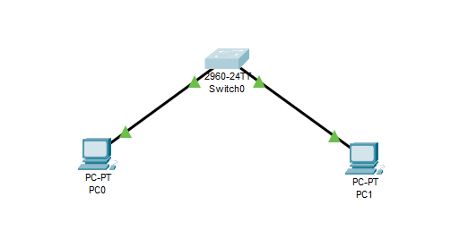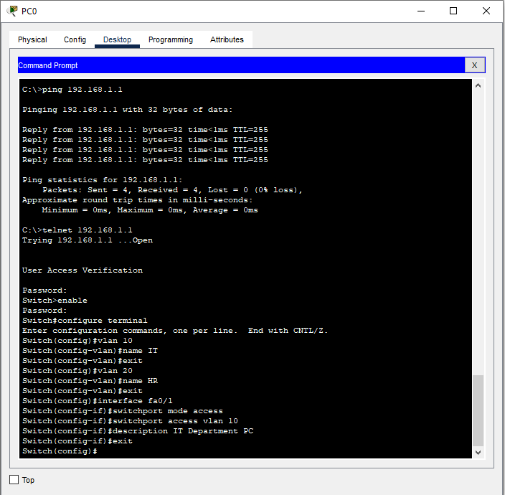

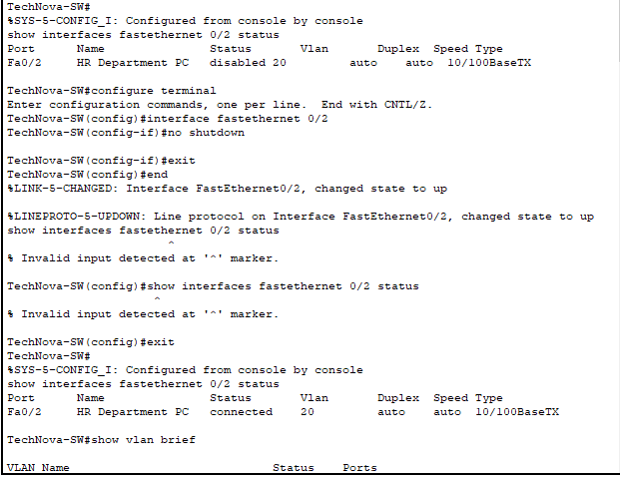

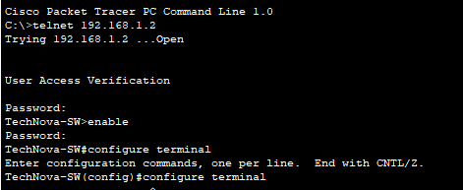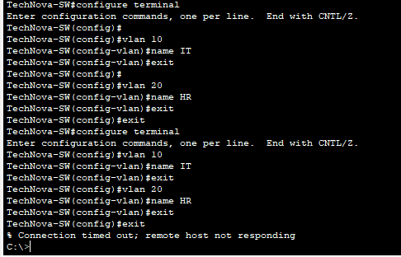
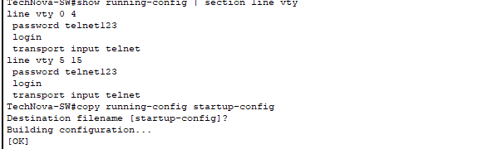
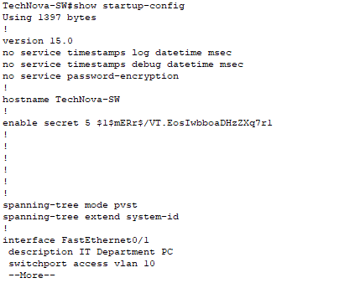
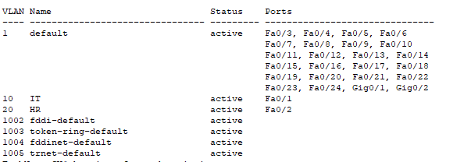
Task 2: NovaTech Office has recently expanded its network by adding a second access switch. The network
administrator manages the network from an administrator workstation located in the IT department. For security
reasons, the administrator wants to remotely manage the Main Switch using SSH instead of Telnet.
The network consists of an Administrator PC, two Cisco switches, and a departmental PC. The Main Switch is
connected to the second switch, while the Administrator PC is directly connected to the Main Switch.
- Connect Admin-PC to the Main Switch.
- Connect Department-PC to the Access Switch.
- Connect the Main Switch and Access Switch so that they can communicate.
- Configure appropriate IP addressing so that the Administrator PC can reach the Main Switch.
- Configure the Main Switch for secure SSH-based remote management.
- Create a local administrator account for remote authentication.
- Configure the required domain information and RSA keys for SSH.
- Ensure that the Main Switch accepts SSH connections only for remote management.
- From Admin-PC, establish an SSH session with the Main Switch.
- Once connected through SSH, remotely create VLAN 20 named SALES on the Main Switch.
- Assign the appropriate port connected to the Access Switch to the required VLAN configuration.
- Configure a suitable description for the switch-to-switch connection.
- Verify the VLAN, port assignment, SSH configuration, and connectivity between the devices.

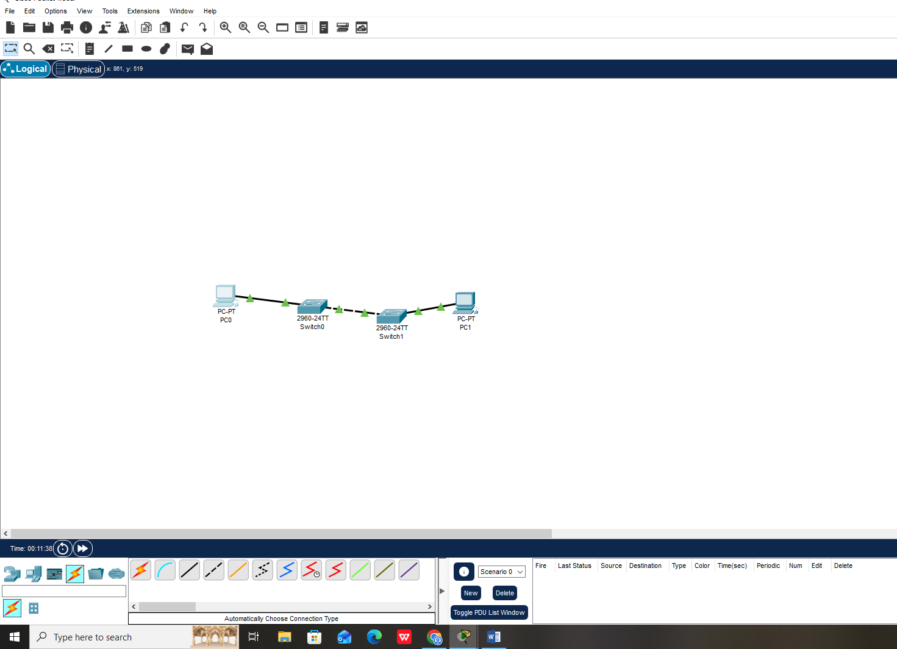
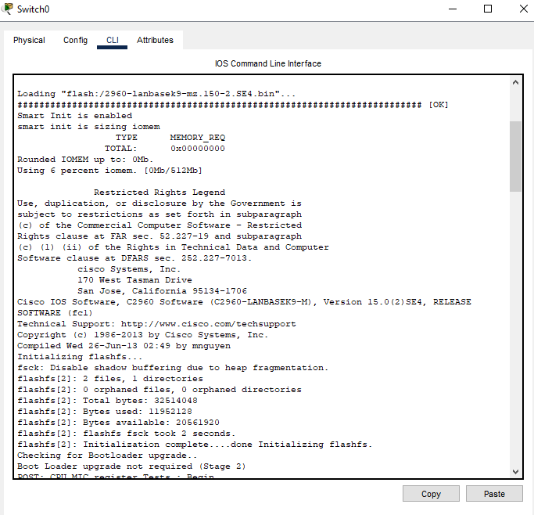

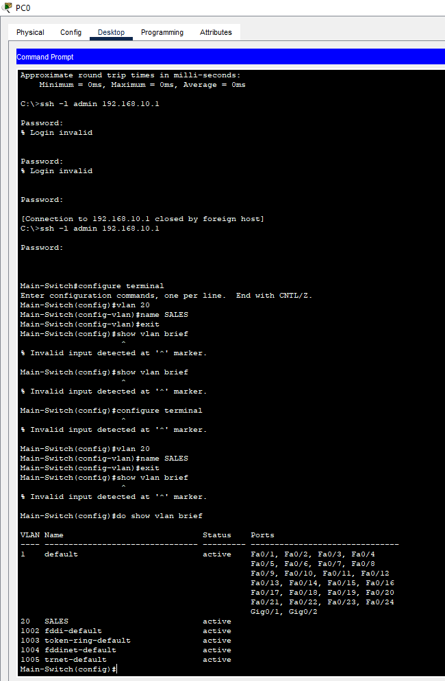
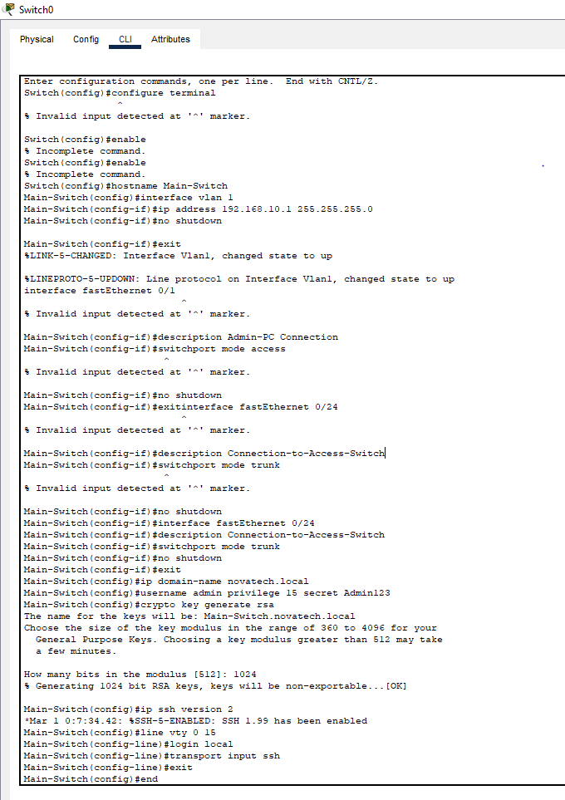

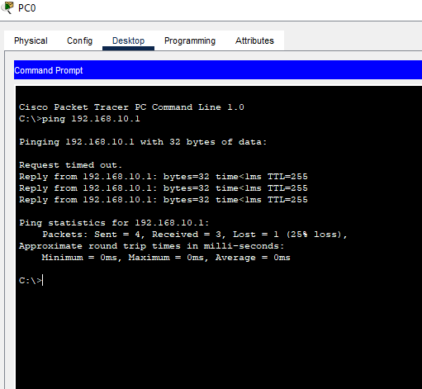

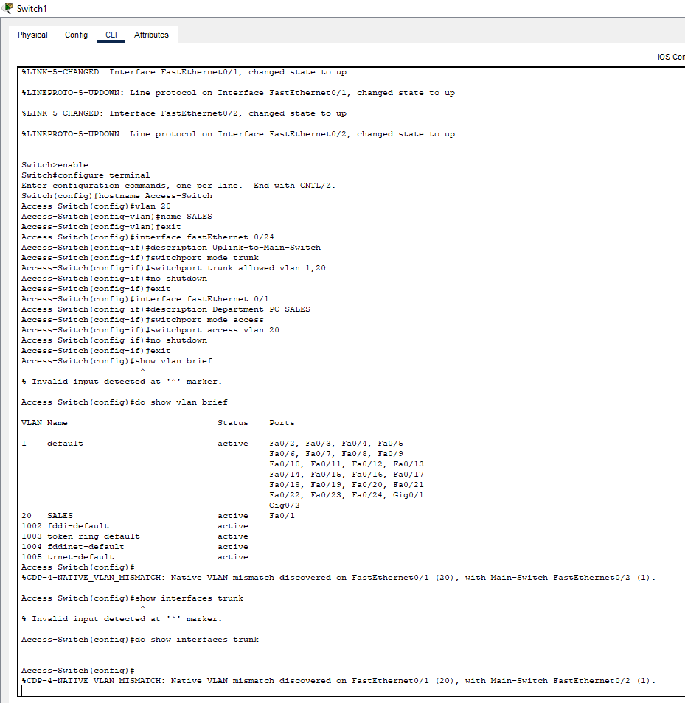

Task 3: TechNova Solutions has two network engineers who are responsible for managing the company’s Cisco switch. For security and accountability, the administrator wants each engineer to access the switch using a separate username and password. Both engineers should be able to establish their own SSH sessions with the switch from different workstations.
Requirements:
1. Configure two separate local user accounts on the switch:
- Engineer 1: Username = eng_ali &amp; Password = AliPass!1
- Engineer 2: Username = eng_sara &amp; Password = SaraPass!2
2. Configure the switch to allow secure remote management through SSH and use the locally configured
accounts for authentication.
3. From PC-Admin, establish an SSH session with the switch using the eng_ali account.
4. Without terminating the first SSH session, use PC-User to establish another SSH session with the same
switch using the eng_sara account.
5. Keep both SSH sessions active and use the switch CLI to check which VTY lines are currently being used
by the connected engineers.
6. Verify that the two engineers are connected through separate VTY sessions and that their individual
usernames are correctly associated with their sessions.
7. Test the authentication by attempting to access the switch using an incorrect username or password and observe whether the switch allows or rejects the connection.
